

**SANYO SN-45FA68 1.7 Ton**

**Rs. 248,100/-**

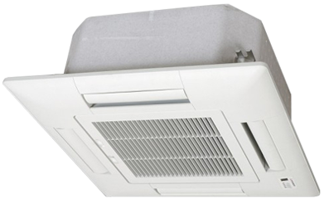

**Product Features**

* concealed LED display
* Intelligent airflow
* precise system control technology
* friendly referigerant R410a
* auto restart after power restored

**Specification**

**Type** Ceiling Cassette AC

**Cooling (Btu/h)** 31000

**Voltage (V)** 220-240

**Power Input (W)** 2800

**EER (Btu/W-h-W/W)** 3.4-1.5